PROJECT REPORT
TEAM DETAILS:
TEAM LEADER: K. LALITHAMBIGAI
TEAM MEMBERS: G.HARINI, K.HARINI, K. GOWTHAMI
1. INTRODUCTION:
1.1 Overview:
First I created an EMPATHY MAP. A map has four quadrants –says, thinks, Does and Feels. next .How do I Prepare for tableau interview. How do you measure the talent management success. What are the critical issues that a talent scorecard should measure? These are all things I shown in my four quardrants.Next I created BRAIN STROM. My team members give some idea for this brainstorm. Then I created my data analysis_ Dashboard and story Next I published my Dashboard and story in the Tableau Public.
1.2 Purpose:
The purpose of the talent management is to identify, recruit and hold on to people who drive the success of your organization. Performance and talent management is a key function of the modern HR department. Talent management in HR also strives to keep existing employees and promote them to more crucial positions in the company. It saves money on high employee turnover. It makes much more sense to grow and retain necessary talent than sourching, hiring, and traing new ones.
2. Problem Definition & Design Thinking:
2.1 Empathy Map:
2.2 Ideation & Brainstorming Map:

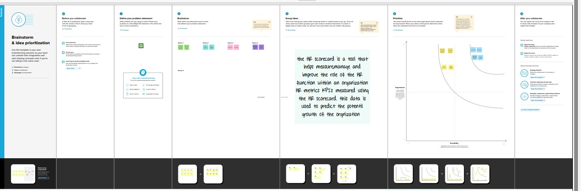
3. RESULT:
DASHBOARD:
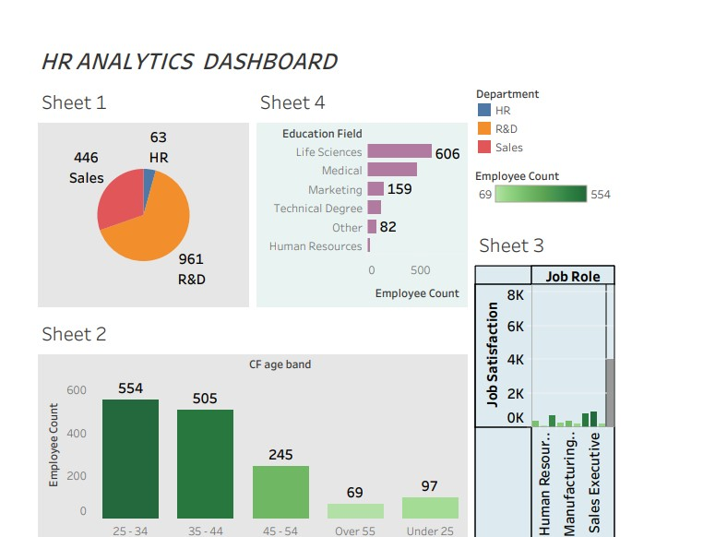

STORY:
Department wise Attrition:
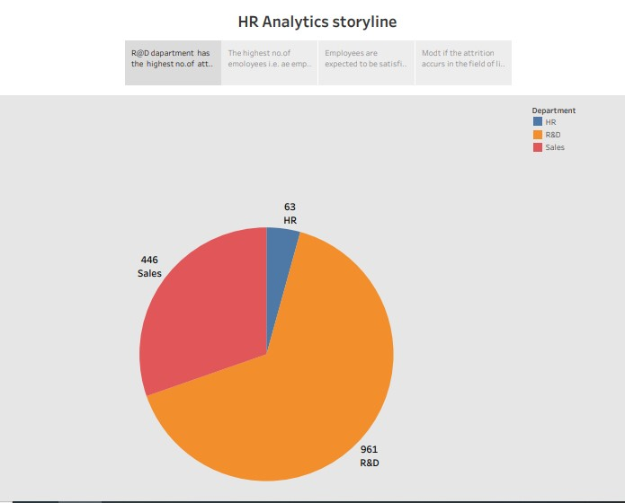

No. of employees by age group :
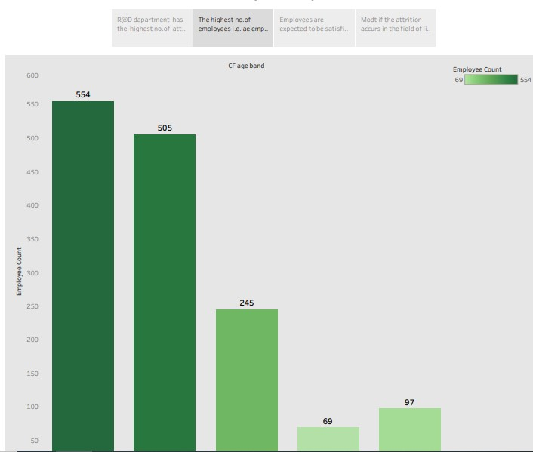

Job Satidfaction Rating :

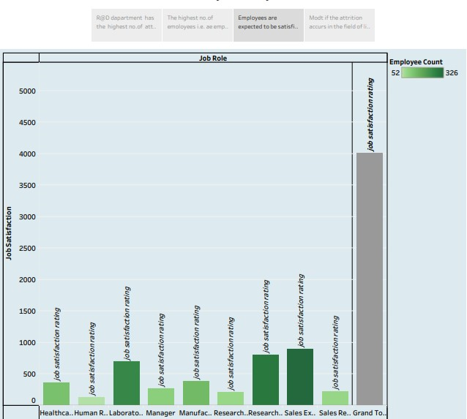

Education Field Wise Attriction :

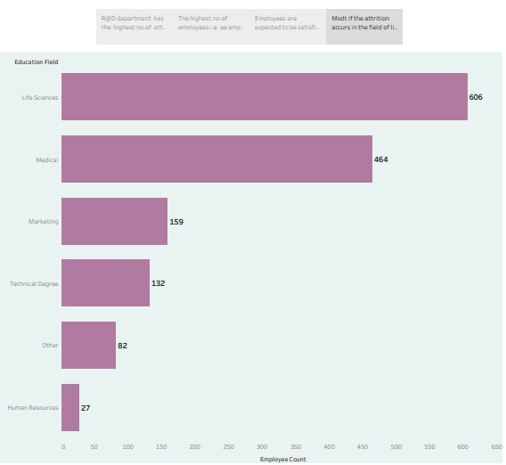

4 ADVANTAGES & DISADVANTAGES :
Advantage :
- Help in ascertaining the right person is deployed in the right position.
- Contributes in retaining their top Talent .
- Better hiring by hiring assessments .
- Helps in understanding employees better and shaping their future.
- Promotes effective communication across different disciplines.
Disadvantages :
- The implementation of talent management program could be expensive in terms of time, resresources and financial costs.
- Lack of support from line managers can impede the level of commitment from employees.
- A core drawback of talent management is, it can contribute in raising the conflicts between HR and management by not reaching to proper agreement or consensus.
5. APPLICATION :
Talent management software provides many advantages in the areas of recruitment ,performance management, training and education ,and compensation management. Companies can collect, centralize,track, store ,report and analyze employee data, while receiving automated remaiders and notifications.

6. CONCLUSION :
Employees leave an organization if their job becomes monotonous or the learning activities stop over time. Talent management focuses on job rotation and encourages the workforce to pick up new skills as per market demand. It keeps them engaged, motivated and enhances employee loyalty.
7. FUTURESCOPE :
HR will always have a scope in future because it is a field that is constantly changing. HR in the future will be combination of technology and people analytics. It is a very dynamic field and one should never worry about scope in HR in near future. The need of HR is increasing day by day.

